Ideation Phase
AI FitTrack – Define the Problem Statements
Date | 24 September 2026
Team ID | SWTID-2026-9501
Project Name | AI FitTrack – AI-Powered Fitness Tracking System
Maximum Marks | 2 Marks
Customer Problem Statement Template:
Create customer-centered problem statements for AI FitTrack so the solution remains grounded in real workout tracking and fitness guidance needs.
A clear problem statement helps identify current behavior, pain points and desired outcomes before selecting features.

Example: AI FitTrack customer problem framing

Problem Statement (PS) | I am (Customer) | I’m trying to | But | Because | Which makes me feel
PS-1 | Fitness user | track workouts consistently | records are scattered or manual | there is no single simple tracking workflow | frustrated and inconsistent
PS-2 | Fitness user | understand progress over time | totals and trends require manual calculation | the user lacks an integrated dashboard | uncertain about progress
PS-3 | Fitness user | get personalized guidance | generic plans do not reflect goal or experience | personalization is difficult to create manually | unsure what to do next
PS-4 | Fitness user | use AI safely | AI access can fail or be misconfigured | external provider permissions are not always available | blocked or confused
Problem Statement Validation
Validate each statement through observation, user interviews or task walkthroughs before treating it as a confirmed requirement.
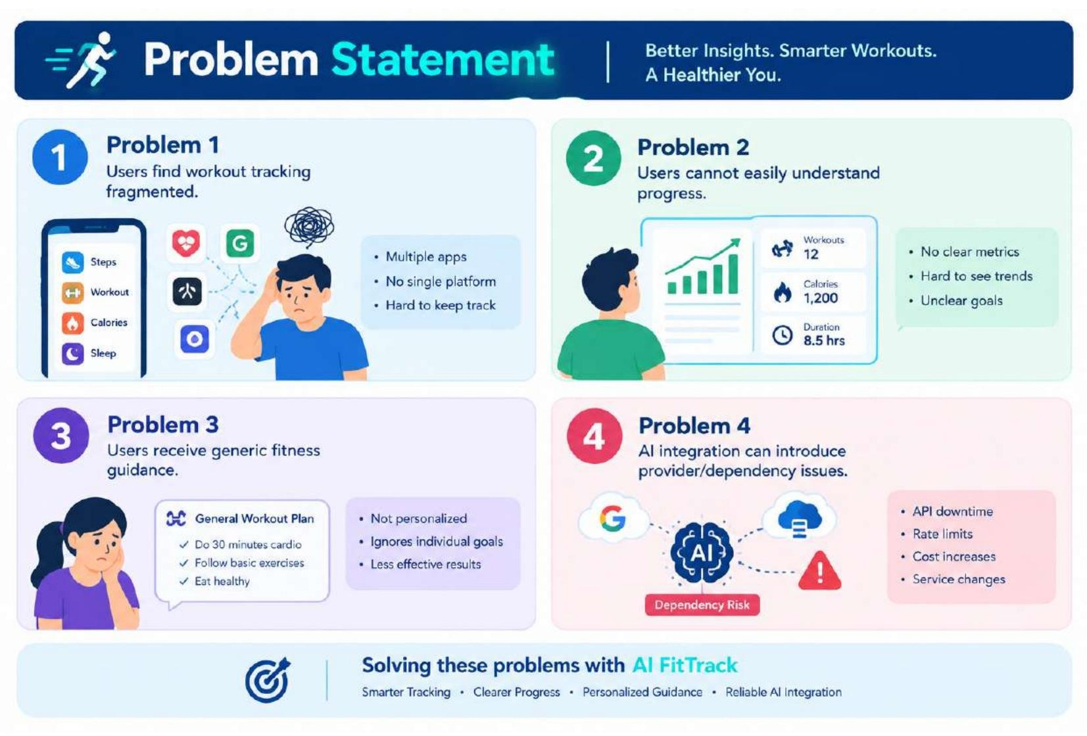
Prioritized Problem Themes
• Consistency of workout recording.
• Visibility of measurable progress.
• Personalized recommendations.
• Secure and reliable access to fitness data.

